


Personal Learning Portfolio

Course： English Academic Writing Teacher： Zhang Mei
Class： 001 Major： 计算机科学与技术
Name： 徐聪 Student Number： 20195371
Class Time： 2022.9-2023.1
Grade：

Self | Teaching Assistant | Teacher

Comments：

Teacher (Signature)
Contents

Week 1
- My learning
  - Class record
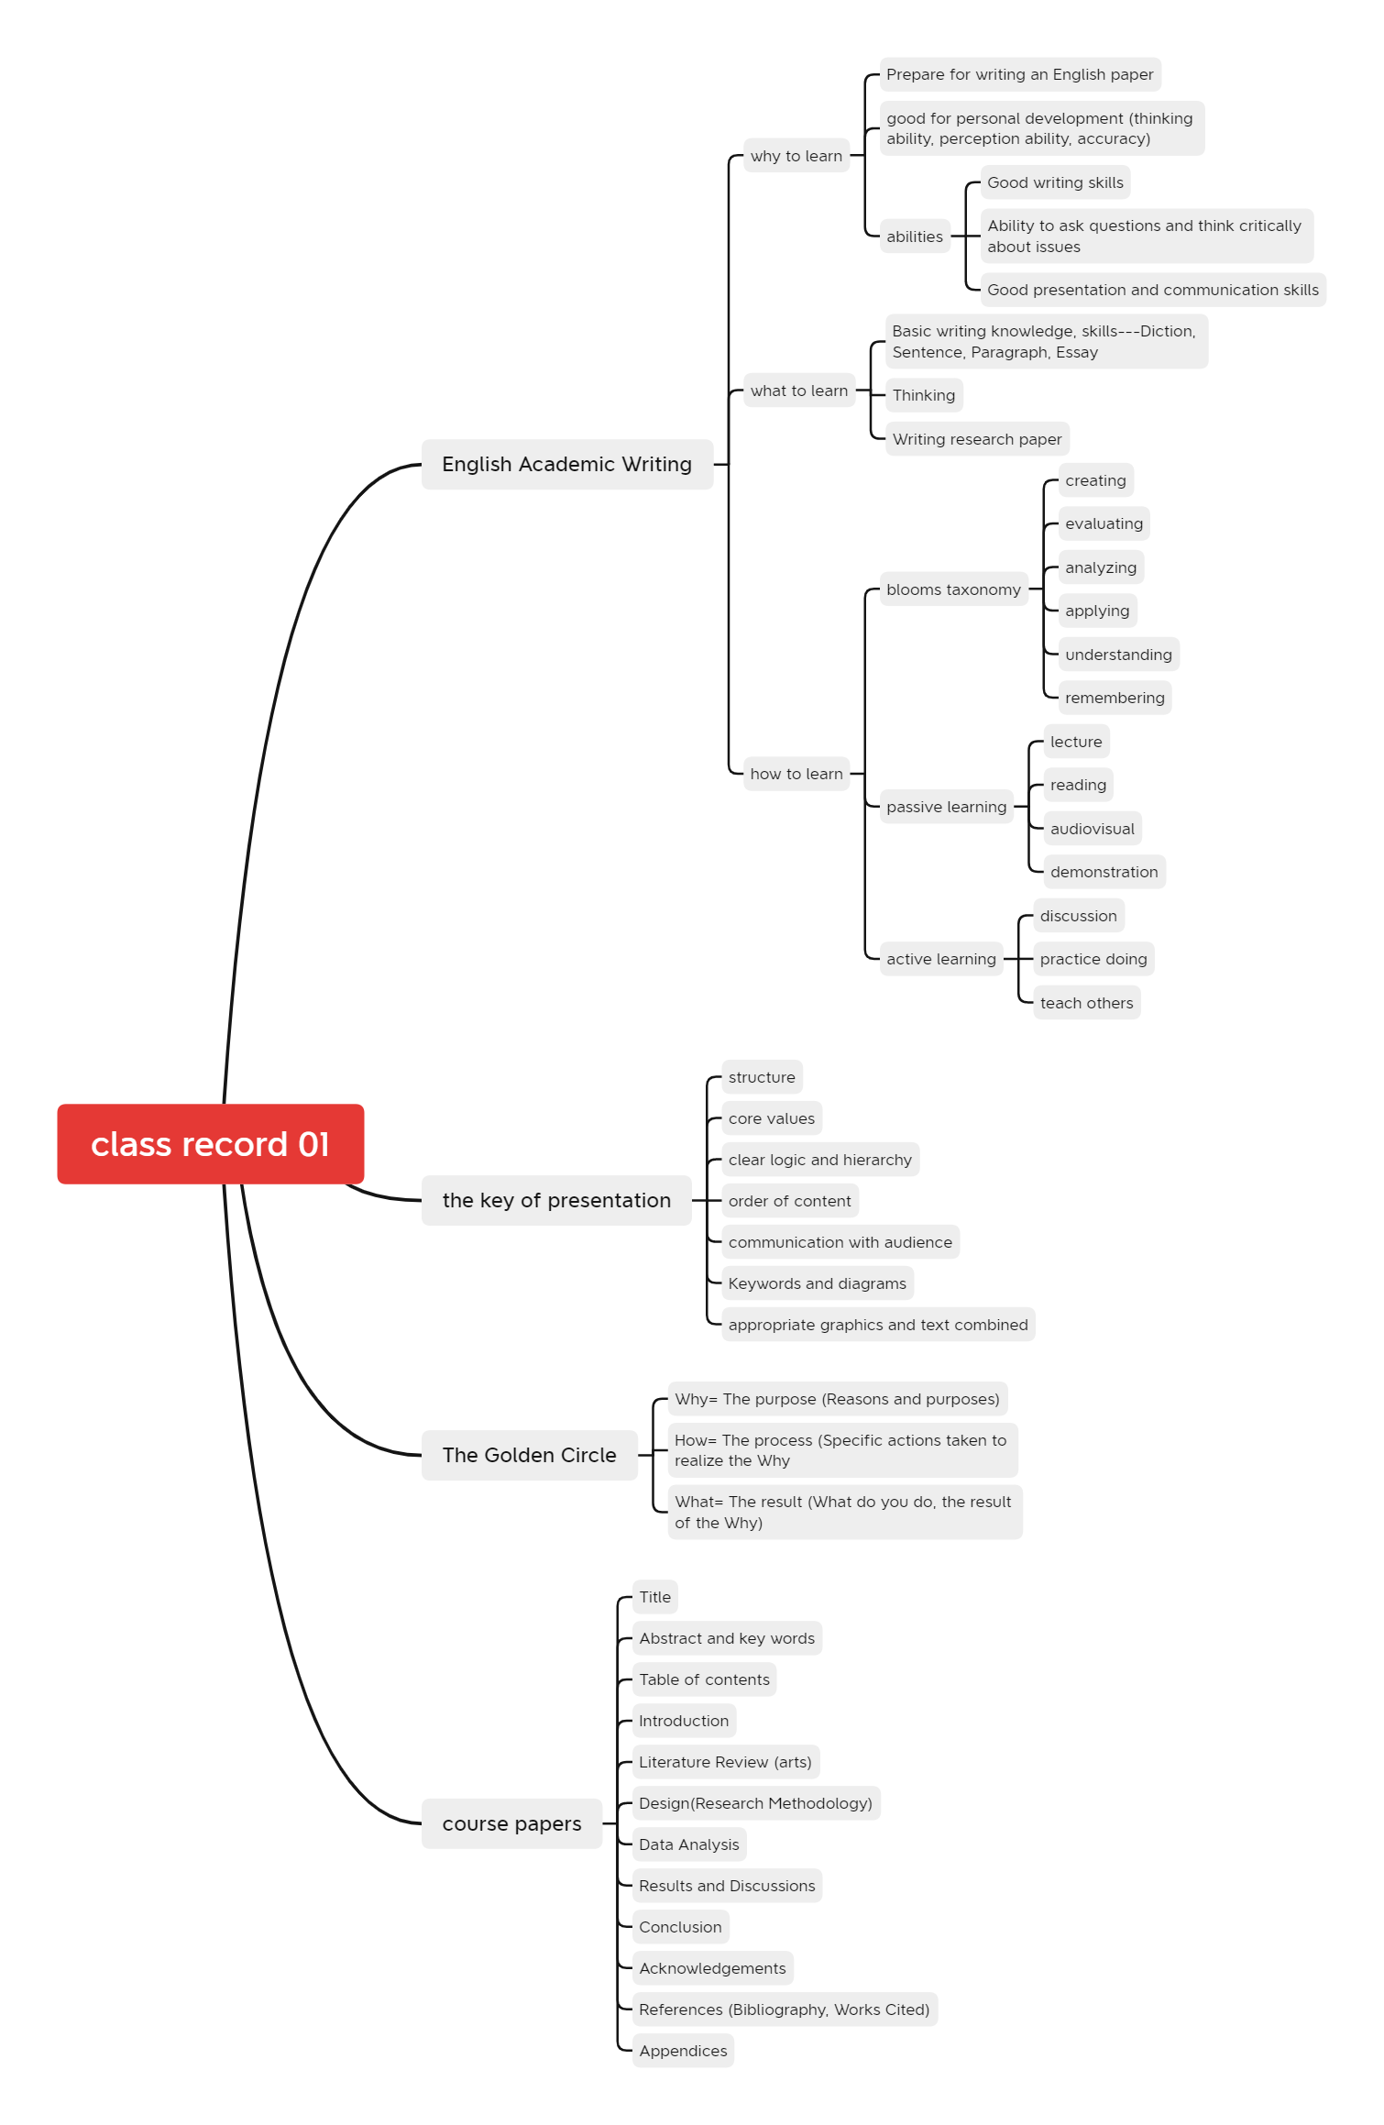
  - Study notes
    - Levels of words
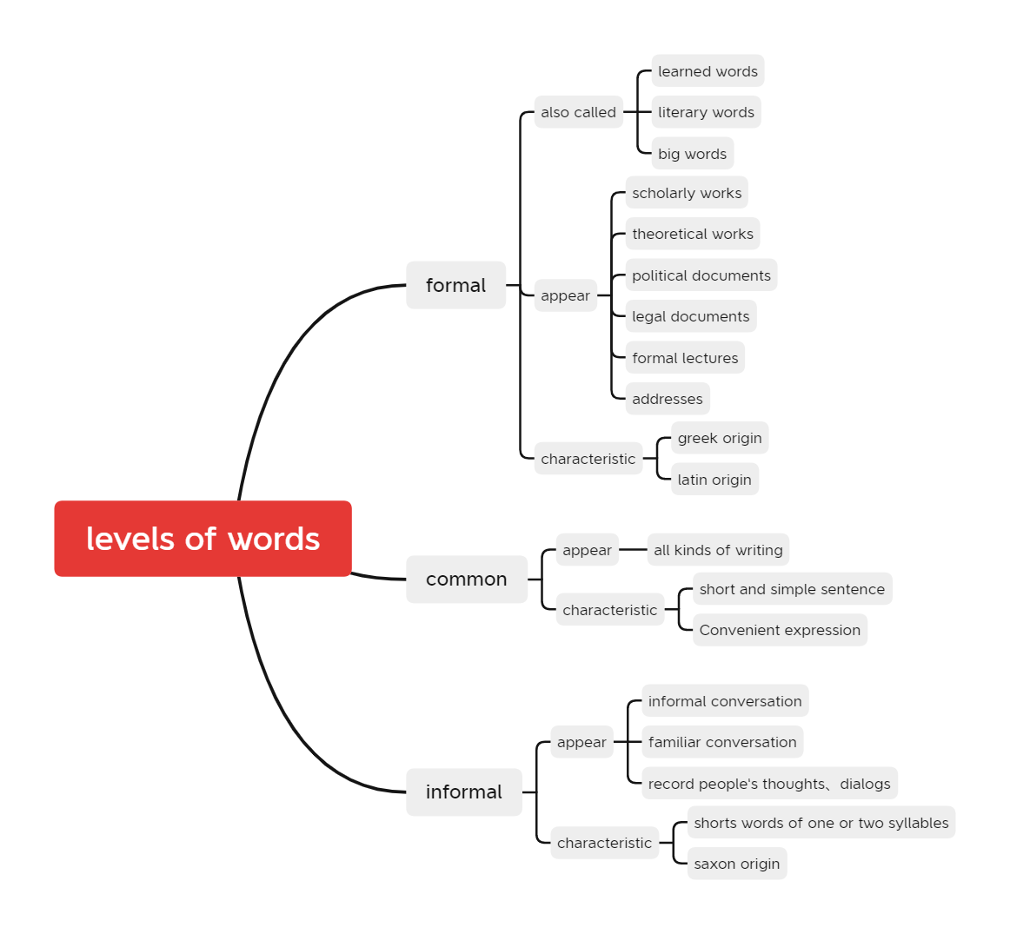
    - Type of sentences
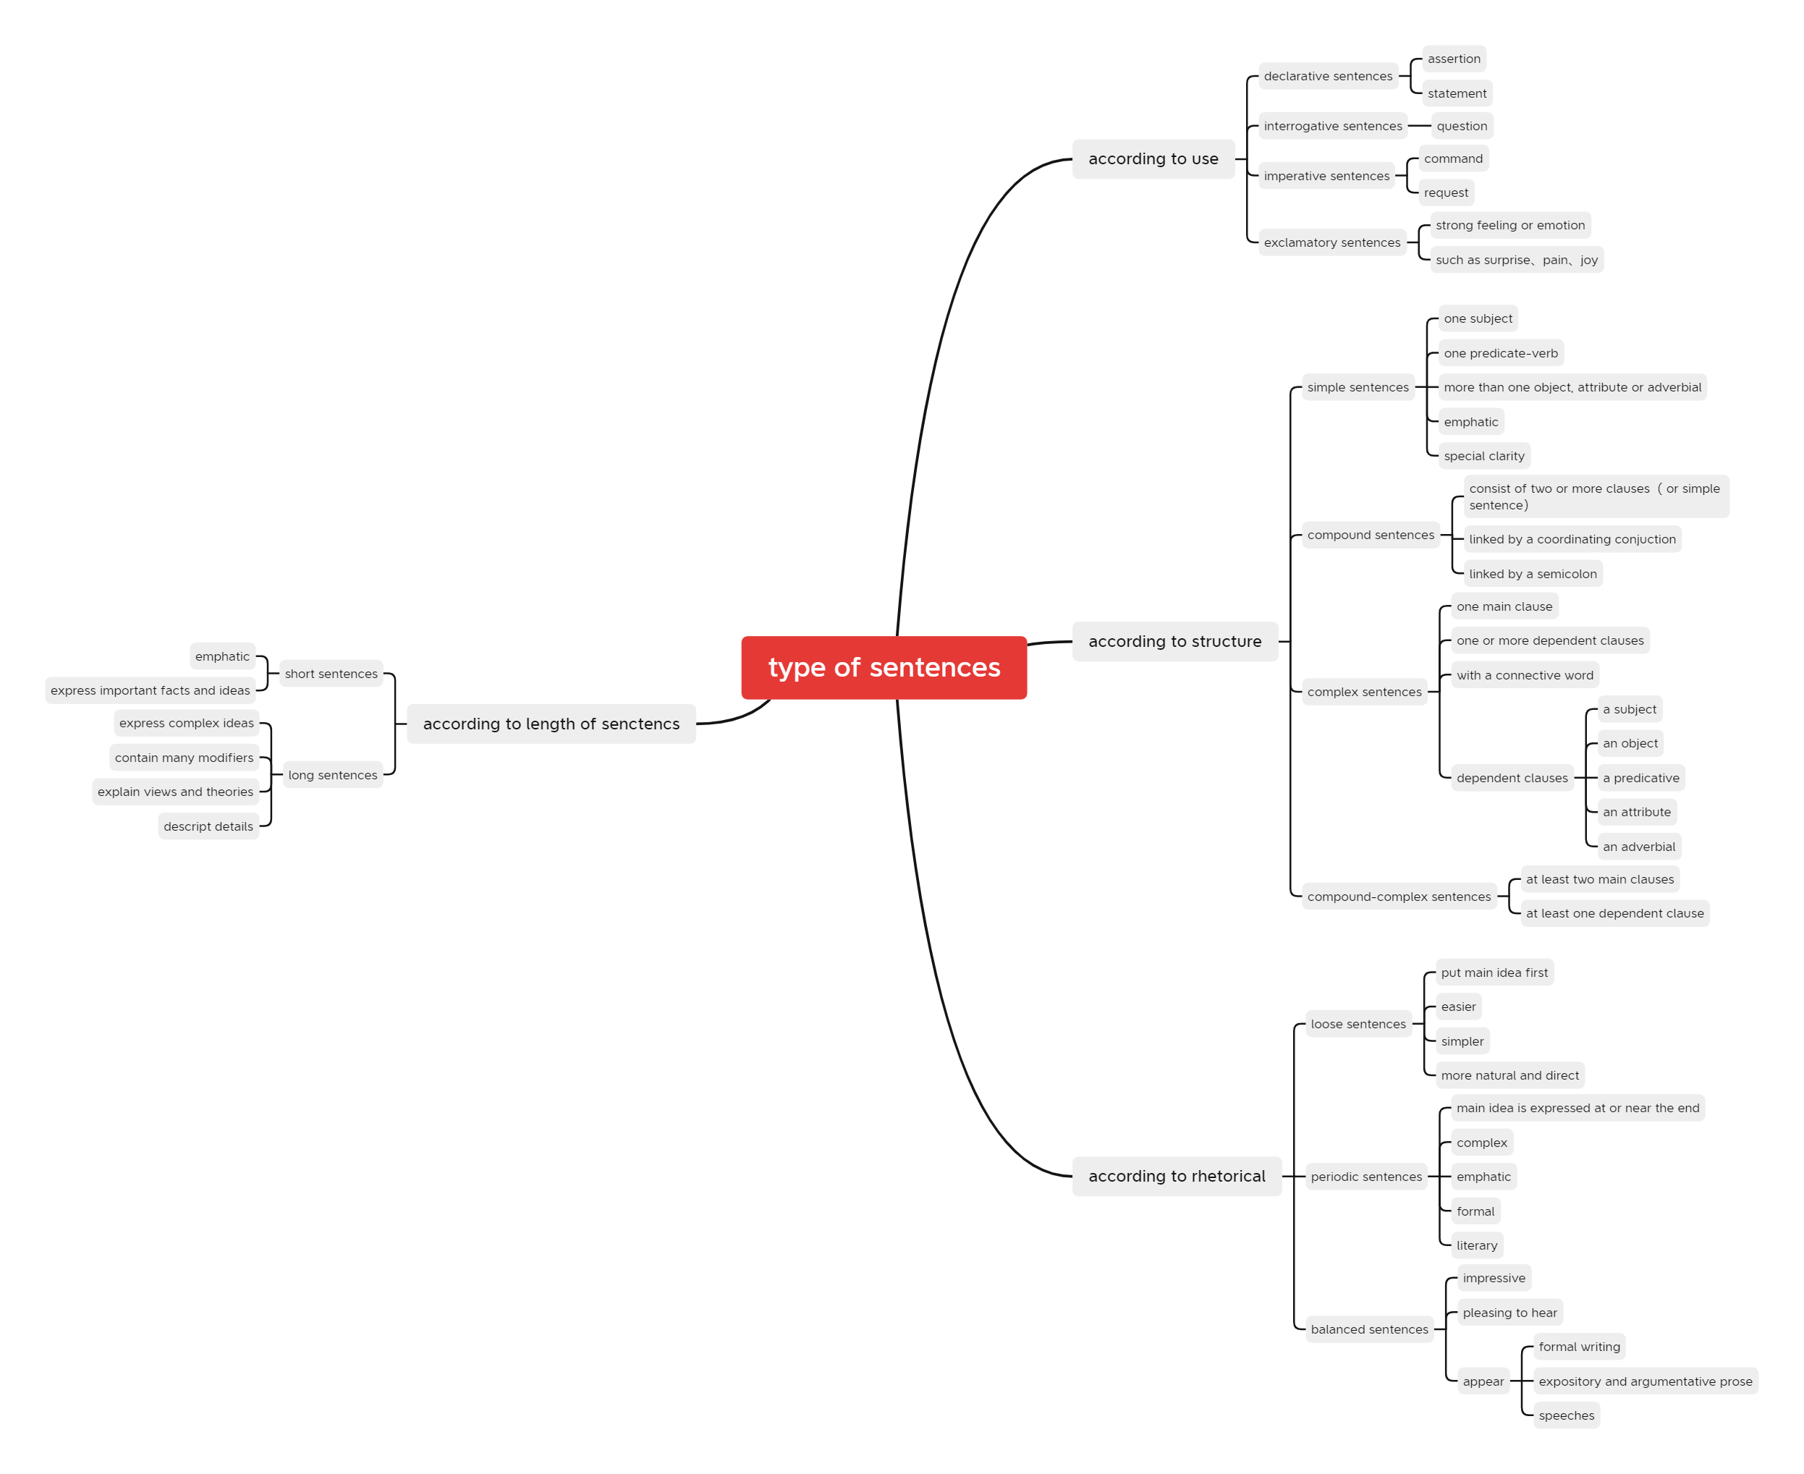
Usage of various types of sentences
- A declarative sentence makes an assertion or a statement.
- An interrogative sentence asks a question.
- An imperative sentence expresses a command or a request.
- An exclamatory sentence expresses a strong feeling or emotion. such as surprise, pain. or joy.
- Short simple sentences are usually emphatic; they have special clarity, and provide variety when used with longer sentences.
- compound sentence consists of two or more independent clauses related to each other in meaning.
- A complex sentence contains one main clause and one or more dependent clauses. with a connective word denoting the relation between the two parts.
- A compound-complex sentence contains at least two main clauses and at least one dependent clause---a combination of a compound and a complex sentence.
- Short simple sentences are often used to make emphatic or important statements.
- Long complex sentences express complex ideas clearly and accurately.

    - Criteria of effective paragraph
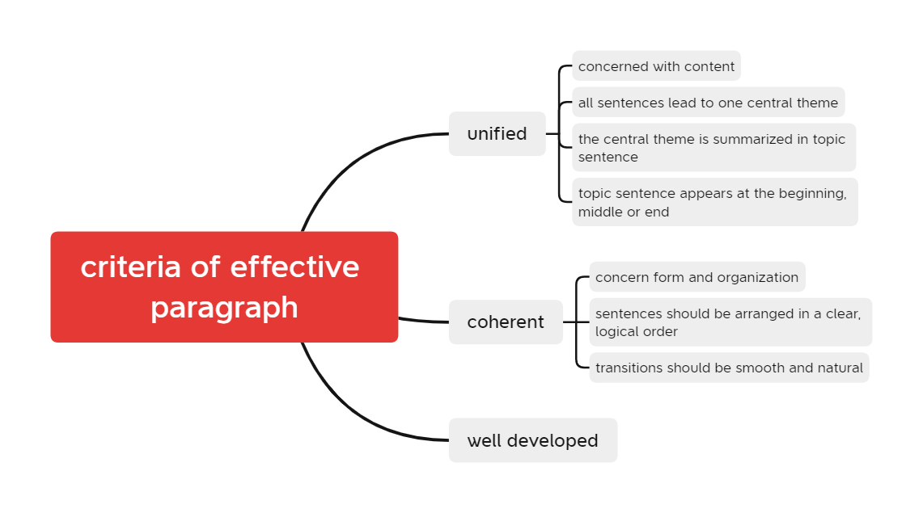
The following ways can help us to write an effective and fluent paragraph:
- Using parallel structures;
- Repeating words or word groups;
- Using pronouns to refer to nouns in preceding sentences;
- Being consistent in the person and number of nouns and pronouns, and the tense of verbs; Using transitional expressions.

    - Structure of a paragraph
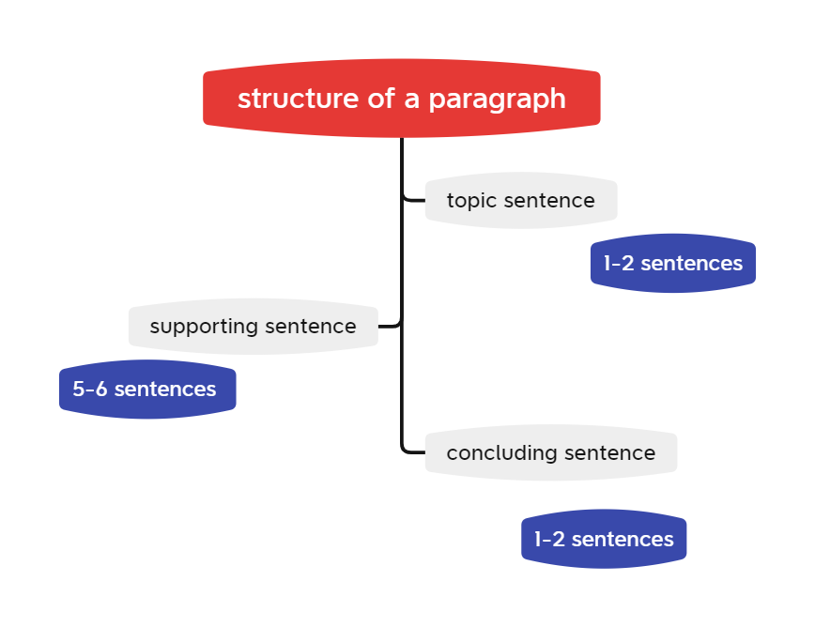
The steps in writing a paragraph
- Think of the topic or theme or main idea, and express it in a complete sentence (topic sentence).
- Think of the details or examples or facts that may be used to support or explain the main idea.
- Work out an outline to arrange the details or examples or facts in logical order. With the outline. the paragraph is almost half-done.

structure of a paragraph
A paragraph is a group of sentences about a single topic. Together, the sentences of the paragraph explain the writer's main idea (most important idea) about the topic. In academic writing, a paragraph is often between five and ten sentences long, but it can be longer or shorter, depending on the topic.

- Learning outcome
  - Learning gains
- The course "Academic English Writing" will improve our ability to read foreign literature, and we can write more standard English papers, which will help us improve our personal skills. Develop writing skills, critical thinking skills, expression and communication skills
- You can improve your academic English writing skills by learning basic grammar knowledge, thinking critically, and writing literature.
- Understood the structural framework of an academic paper
- Learned some basics about vocabulary, sentences, and paragraphs

  - Future applications
- In ppt production we need to pay attention to font size, color, oral presentation and ppt synchronization, and audience interaction
- The golden circle rule structure, PREP structure can be used for presentations, defense, writing, reporting and other scenarios

- My behavior and attitude
3.1. Out of Class
3.1.1. Autonomous learning
1) Online
Studied the Academic English Course on the mooc platform seriously and acquired more knowledge about English writing

2) Offline
Read relevant books on English writing and 2-3 English literature

3.1.2. Homework
Complete the《英语写作手册》 Levels of Words (P.7-10), Types of Sentences (P.37-43), Criteria of an Effective Paragraph (P.64-68), Steps in Writing a Paragraph (P.71-72 ). And summarize the week's learning and give examples of future applications of the knowledge points. Attitude certification and completing assignments on time

3.2. In Class
Actively participate in class discussions and answer questions from the teacher. Serious attitude and active participation in presentations. Take careful class notes as well as mind maps.

4．Improvement
  - Adequate preparation for the class
Pre-learning preparation of new knowledge, pre-learning of new knowledge should mainly grasp the difficult points, clear listening focus.

  - Listen to the lecture with full attention
Listen to the lecture with full concentration, i.e. with high concentration, participate in the lecture seriously, and do not have two minds.

  - Active and serious thinking
Learning is inseparable from thinking, and listening is a major form of learning for students, and it is also inseparable from thinking.

  - Take good classroom notes
To take class notes, write down the main chapter headings and subheadings to capture the theme of each section. In addition, record the teacher's insights and thinking about the issues, and add notes if necessary.

Week 2
- My learning
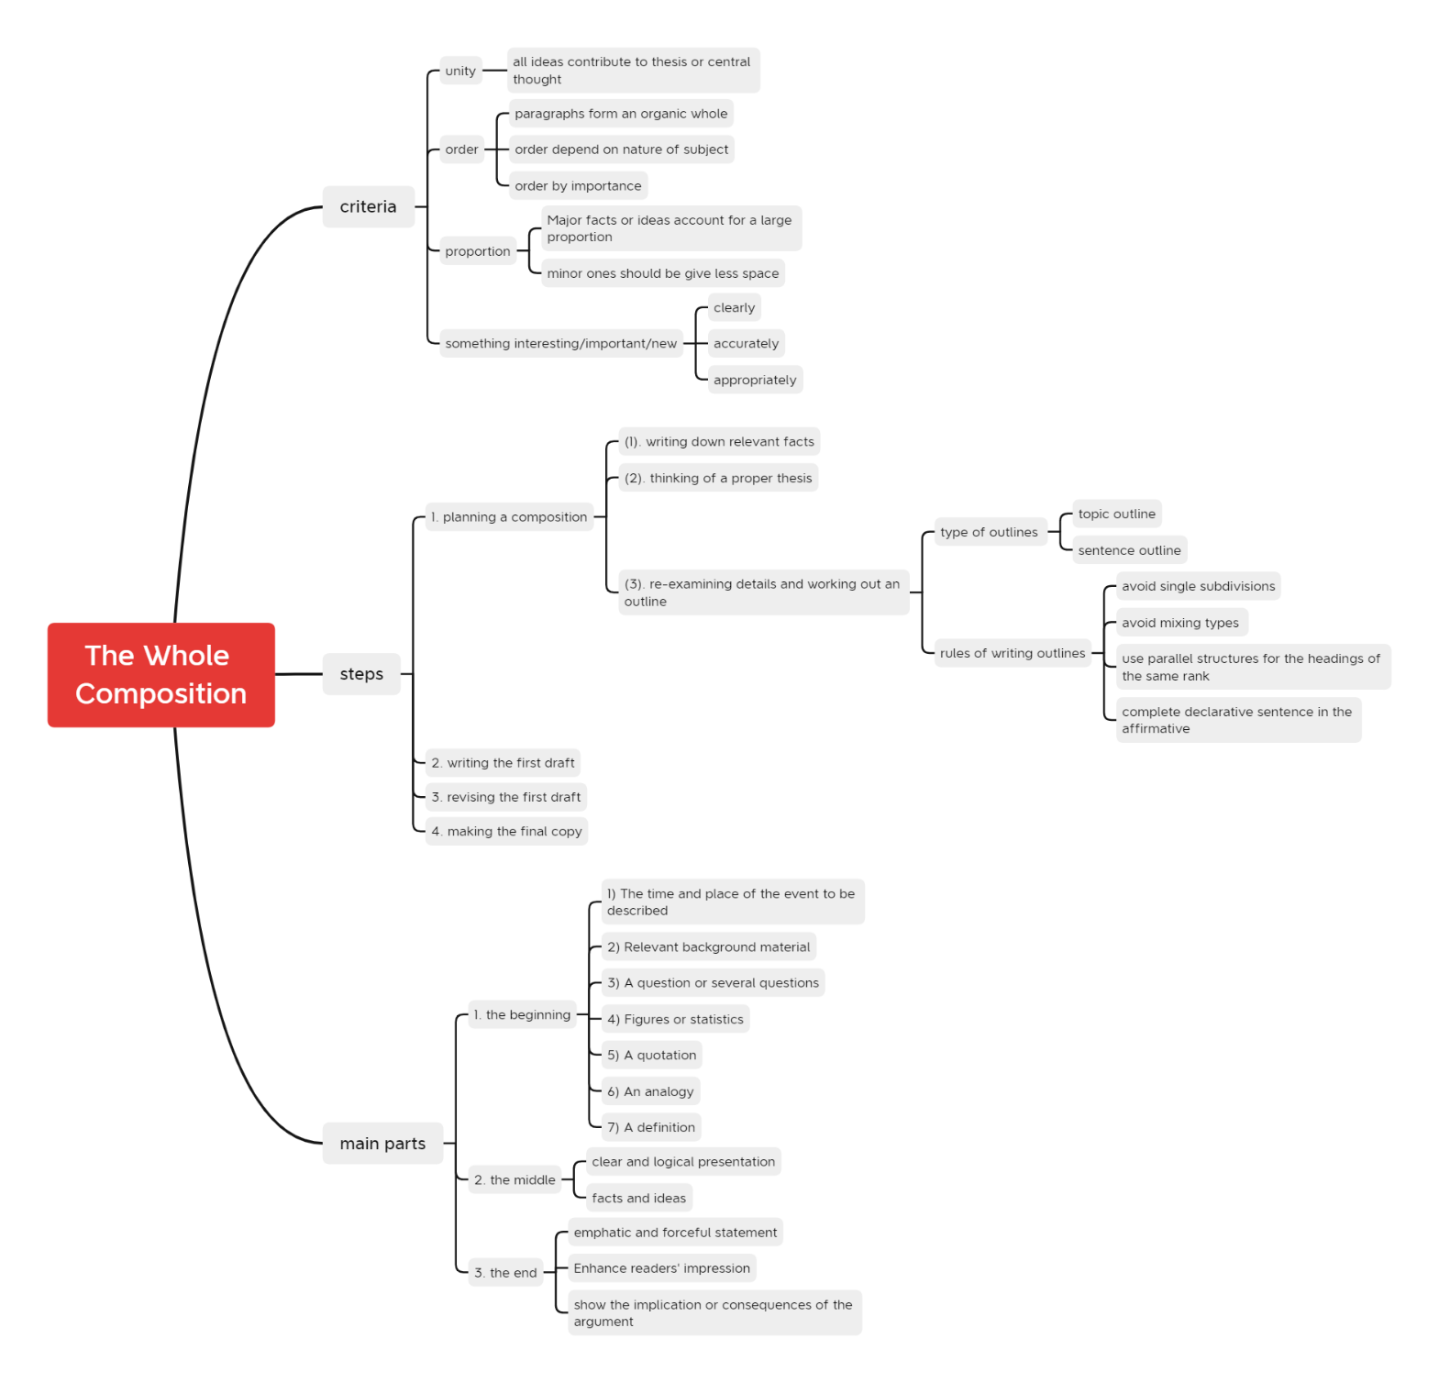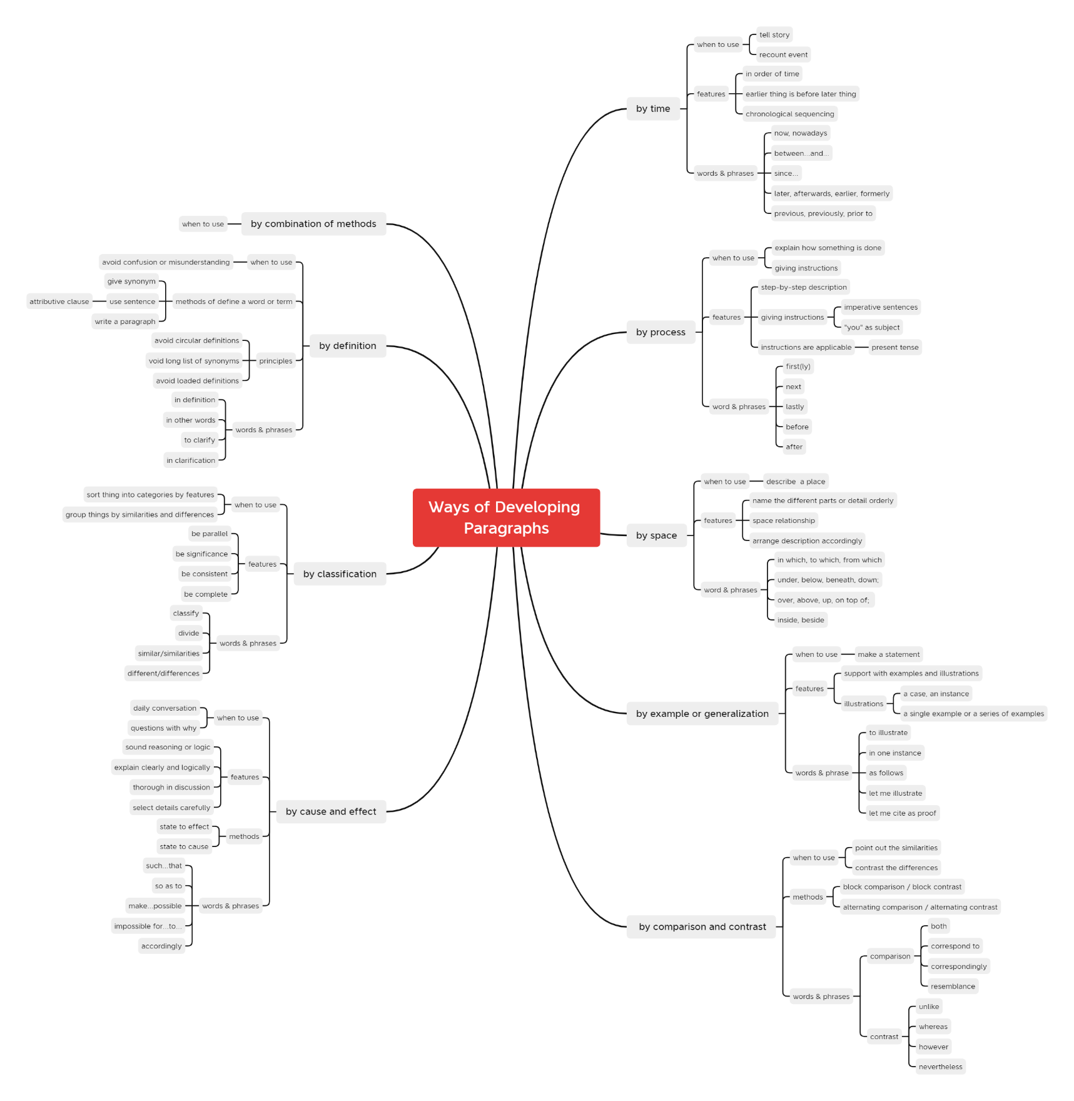
- Learning outcome
- Through study, I have mastered the method of developing a paragraph, for example, by process, by cause and by effect, by comparison and contrast, and so on.
- In the process of developing a paragraph, we should use various methods flexibly. Improve my English writing ability through continuous training
- Through learning the basic steps of writing composition and knowing the four common types of composition, I will apply them in my future life

3. My behavior and attitude
3.1. Out of Class
3.1.1. Autonomous learning
1) Online
Studied the Academic English Course on the mooc platform seriously and acquired more knowledge about English writing

2) Offline
Read relevant books on English writing and 2-3 English literature

3.1.2. Homework
Read英语写作手册P.72-115. Write a learning report 2 (mind map + listing)

3.2. In Class
Actively participate in class discussions and answer questions from the teacher. Serious attitude and active participation in presentations. Take careful class notes as well as mind maps.

4．Improvement

  - Adequate preparation for the class
Pre-learning preparation of new knowledge, pre-learning of new knowledge should mainly grasp the difficult points, clear listening focus.

  - Listen to the lecture with full attention
Listen to the lecture with full concentration, i.e. with high concentration, participate in the lecture seriously, and do not have two minds

  - Active and serious thinking
Learning is inseparable from thinking, and listening is a major form of learning for students, and it is also inseparable from thinking.

  - Take good classroom notes
To take class notes, write down the main chapter headings and subheadings to capture the theme of each section. In addition, record the teacher's insights and thinking about the issues, and add notes if necessary.

Week 3
- My learning
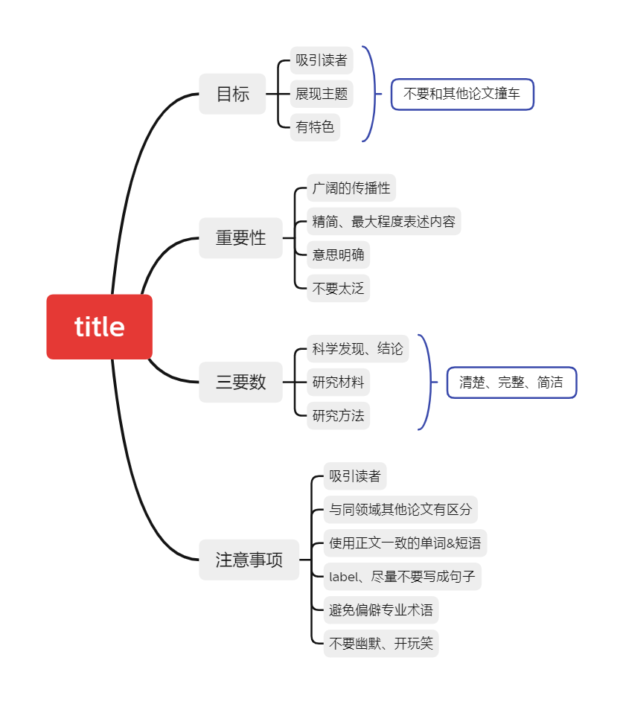
- Learning outcome
- Learned the three essentials of paper title and the specification of paper title
- Clarified the notes for writing the paper title

- My behavior and attitude

1）Out of Class
1.1 Autonomous learning
1.1.1 Online
Studied the Academic English Course on the mooc platform seriously and acquired more knowledge about English writing
1.1.2 Offline
Read relevant books on English writing and 2-3 English literature

1.2 Homework
（1）Surf the Internet and watch中国大学MO0C科学研究方法与论文写作的第十六章
（2）Decide on the title (Chinese)of your course paper

2）In Class
2.1 Individual performance
Actively participate in class discussions and answer questions from the teacher. Serious attitude and active participation in presentations. Take careful class notes as well as mind maps.

4．Improvement

  - Adequate preparation for the class
Pre-learning preparation of new knowledge, pre-learning of new knowledge should mainly grasp the difficult points, clear listening focus.
  - Listen to the lecture with full attention
Listen to the lecture with full concentration, i.e. with high concentration, participate in the lecture seriously, and do not have two minds.
  - Active and serious thinking
Learning is inseparable from thinking, and listening is a major form of learning for students, and it is also inseparable from thinking.
  - Take good classroom notes
To take class notes, write down the main chapter headings and subheadings to capture the theme of each section. In addition, record the teacher's insights and thinking about the issues, and add notes if necessary.

Week 4
- My learning
Basic requirements of title
- The title should be located at the top of the first page.
- The title of the paper should not be a slogan-style title. The most basic requirement is to summarize the central thesis of the paper directly and distinctly in order to attract the reader's attention.
- The title of the paper must be considered to help in the selection of keywords, preparation of the title list, indexing, etc., which can provide specific practical information for secondary literature search.
Formatting requirements for titles
- Capitalize all letters of the title.
- The first letter of each word is capitalized
- The first letter of the first word of the title is capitalized, and the rest of the letters are lowercase.
- Learning outcome
- Learned how to write scientific paper titles
- Developed presentation skills

- My behavior and attitude
1）Out of Class
1.1 Autonomous learning
Studied the Academic English Course on the mooc platform seriously and acquired more knowledge about English writing

1.2 Homework
- Decide on the title of course paper
- Make PPT, including significance, values, method of this research
- Prepare for presentation in class

2）In Class
2.1 Individual performance
Actively participate in class discussions and answer questions from the teacher. Serious attitude and active participation in presentations. Take careful class notes as well as mind maps.

4．Improvement

  - Adequate preparation for the class
Pre-learning preparation of new knowledge, pre-learning of new knowledge should mainly grasp the difficult points, clear listening focus.
  - Listen to the lecture with full attention
Listen to the lecture with full concentration, i.e. with high concentration, participate in the lecture seriously, and do not have two minds.
  - Active and serious thinking
Learning is inseparable from thinking, and listening is a major form of learning for students, and it is also inseparable from thinking.
  - Take good classroom notes
To take class notes, write down the main chapter headings and subheadings to capture the theme of each section. In addition, record the teacher's insights and thinking about the issues, and add notes if necessary.

Week 5
- My learning
What the introduction should contain
- The introduction of the paper can be understood as a funnel structure, narrowing down from a broad academic field to the purpose of the research:
- Research Background: Gives the background and importance of the research, narrowing from the general trends in the academic field to the research topic to be discussed
- Research Gap: Identifies an area that has not been covered or a problem that has not been thoroughly researched
- Research Question: Explain how the thesis research question corresponds to the research gap, and briefly analyze how the research gap is filled
- Research Methodology: Briefly outline what the research methodology is and why you chose it, but do not go into details.
- Purpose of the research: The purpose of the research can be broken down into smaller points according to the specific content of the essay, which will also allow the supervisor to know the general outline of the subsequent content

- Learning outcome
- Learned how to write an introduction to a paper
- Learned how to write a scientific paper

Evaluation of the presentation of classmates
name | strengths | weaknesses
明成 | ppt theme with bright and beautiful colors、Smooth expression
李佳明 | ppt theme with bright and beautiful colors | Overly detailed catalog
陈慈伊 | Smooth expression | The ppt is relatively monotonous,  the animation is not very coherent
刘江 | Thesis points are very complete | The ppt text is more, not easy for  the audience to understand
田时雨 | ppt color scheme rich
刘淑文 | Red font marked red is good for viewers to catch the focus
熊昊然 | Academic sentences are long and not easy to understand
吴卓萱 | The categories are very complete and the overview is very detailed
方正 | The tables are clear and the charts are very visual
陈秦 |  | No summary points
谭正杨 |  | No clear table of contents, entire text,  no overview of the focus

- My behavior and attitude
1）Out of Class
1.1 Autonomous learning
Studied the Academic English Course on the mooc platform seriously and acquired more knowledge about English writing

1.2 Homework
- Designing a table of contents.
- Look at the Chinese university MOOC "scientific research methods and essay writing" - Fudan University (Lu Baorong) Chapter 18 How to write an introduction.
- Write introduction

2）In Class
2.1 Individual performance
Actively participate in class discussions and answer questions from the teacher. Serious attitude and active participation in presentations. Take careful class notes as well as mind maps.

4．Improvement

  - Adequate preparation for the class
Pre-learning preparation of new knowledge, pre-learning of new knowledge should mainly grasp the difficult points, clear listening focus.

  - Listen to the lecture with full attention
Listen to the lecture with full concentration, i.e. with high concentration, participate in the lecture seriously, and do not have two minds.

  - Active and serious thinking
Learning is inseparable from thinking, and listening is a major form of learning for students, and it is also inseparable from thinking.

  - Take good classroom notes
To take class notes, write down the main chapter headings and subheadings to capture the theme of each section. In addition, record the teacher's insights and thinking about the issues, and add notes if necessary.

Week 7
- My learning
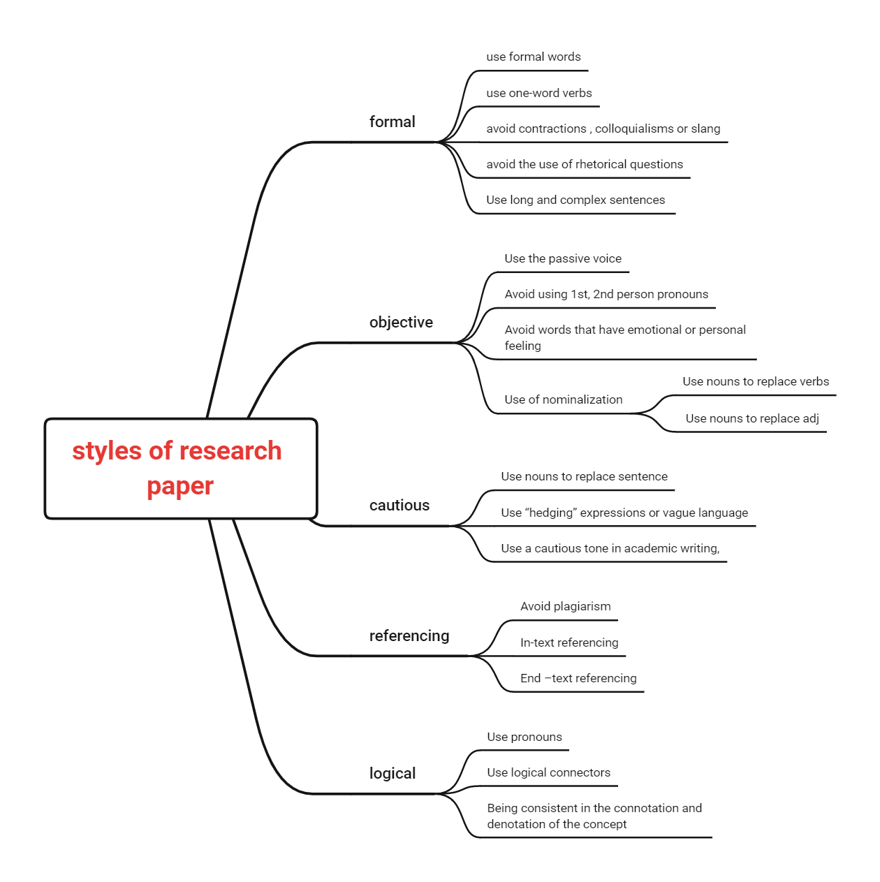
- Learning outcome
  - Definition of literature review
A literature review is a style of writing written after a topic has been identified, based on extensive reading and understanding of the literature in the research area covered by the topic, comprehensive analysis, summarizing and commenting on the research status and development prospects of the research area, and putting forward one's own opinions and research ideas.

  - Contents of the literature review
Abstract, introduction, main body, and references.

  - How to write each part of the literature review
Abstract: The abstract is limited to 200 words or less. The abstract should be independent and self-contained, without diagrams, lengthy formulas, and non-public symbols and abbreviations. Three to five key words need to be given after the abstract, separated by a semicolon ";".
Introduction:
(a) Begin by stating the purpose of writing and defining the review topic, problem, and research area.
(b) Identify general trends in the published literature on the review topic and set forth definitions of relevant concepts.
(c) Define the scope of the review, including the range of disciplines covered by the topic and the time frame, and must state the year from which the literature is cited, the guidelines for interpreting, analyzing, and comparing the literature and for organizing the order of the review.
(d) Outline the current status of the issue in question or the focus of the debate, leading to the core theme of the review being written, which is of most interest and interest to the general reader and is the main line of writing the review.
Main body: The writing style is varied and there is no fixed format. The literature collected should be summarized, organized and analyzed for comparison, and the historical background, current status and development direction of the review topic established in the introduction section should be clarified, as well as a review of these issues. The topic section should pay special attention to the literature cited and reviewed in a representative, scientific and creative manner. The subject matter can be structured flexibly depending on the type of review.
References: The number of references in general reflects the breadth and depth of the literature read by the author. The number of references for a review paper varies from journal to journal, but generally within 30 articles is appropriate, with the latest literature within 3-5 years being the main focus.

- My behavior and attitude
1）Out of Class
1.1 Autonomous learning
Studied the Academic English Course on the mooc platform seriously and acquired more knowledge about English writing

1.2 Homework
1) Revise Introduction according to the teacher's lecture and the word document "Requirements and Criteria for Introduction" sent by the teacher in the group.
2) Review the definition of a literature review, what parts of a literature review are included, and how to write each part of a literature review.
3) Review literature related to your topic and submit your research tools (questionnaires and interview outlines) to Cloud Class.
4) Complete your personal learning portfolio for the week.

2）In Class
2.1 Individual performance
Actively participate in class discussions and answer questions from the teacher. Serious attitude and active participation in presentations. Take careful class notes as well as mind maps.

4．Improvement

  - Adequate preparation for the class
Pre-learning preparation of new knowledge, pre-learning of new knowledge should mainly grasp the difficult points, clear listening focus.
  - Listen to the lecture with full attention
Listen to the lecture with full concentration, i.e. with high concentration, participate in the lecture seriously, and do not have two minds.
  - Active and serious thinking
Learning is inseparable from thinking, and listening is a major form of learning for students, and it is also inseparable from thinking.
  - Take good classroom notes
To take class notes, write down the main chapter headings and subheadings to capture the theme of each section. In addition, record the teacher's insights and thinking about the issues, and add notes if necessary.

